Personal Introduction Program – Internship Week 1
- Project Description:
This project is a simple Python program developed as part of the first week of the internship.It collects user information such as name, age, hobby, and city, and displays a friendly welcome message.

- Objectives:
• Learn Python basics
• Understand input/output operations
• Use variables effectively
• Write and execute a Python script

- Setup Instructions:
• Install Python 3.x
• Download or clone the project repository
• Open terminal or command prompt
• Run the command:
python personal_intro.py

- Code Explanation:
• input() is used to take user input
• Variables store user information
• print() and f-strings are used to display formatted output

- Technical Requirements Mapping:
Requirement | Implemented
input() used | ✅
Variables used | ✅
print() used | ✅
3+ questions | ✅
Friendly output | ✅

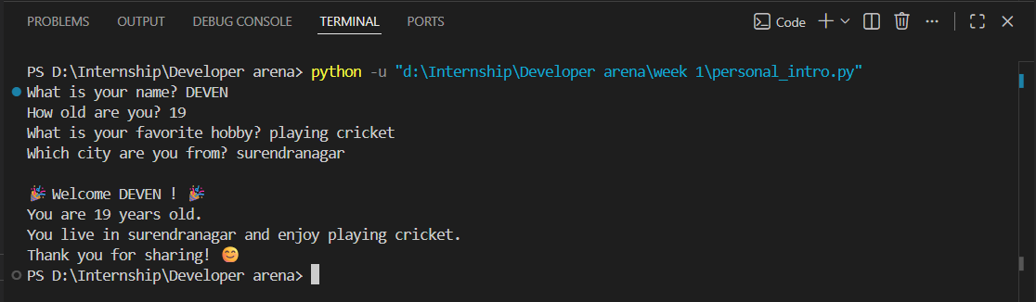

- What I Learned:
• Python syntax basics
• User interaction using input()
• Writing clean and readable code
• Basic GitHub project structure
• Importance of documentation

